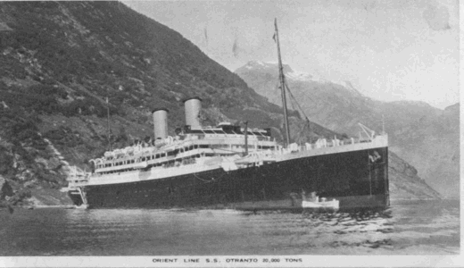

**SS. Otranto**

**Tonnage: 20,032tons - Length: 200,6 m - Beam: 22,9 m - Speed: 20 kn - Operating life: 1929 - 1957 Orient Line. - Built: 1929 Vickers-Armstrongs, Barrow-in-Furness, England - Passengers: 1,686 - She was built for London - Brisbane line.   
In 1939 she became a troopship for the Ministry of War Transport, London.  
In 1949 she resumed passenger service on the route London - Sydney. In 1957 she was scrapped at Faslane, Scotland.  
Otranto was one of five liners of 20,000 tonnes built to replace tonnage lost during the first world war. She survived the second conflict serving as a troop ship, although three of her sister ships, Orama, Orford and Oronsay were lost**

